1.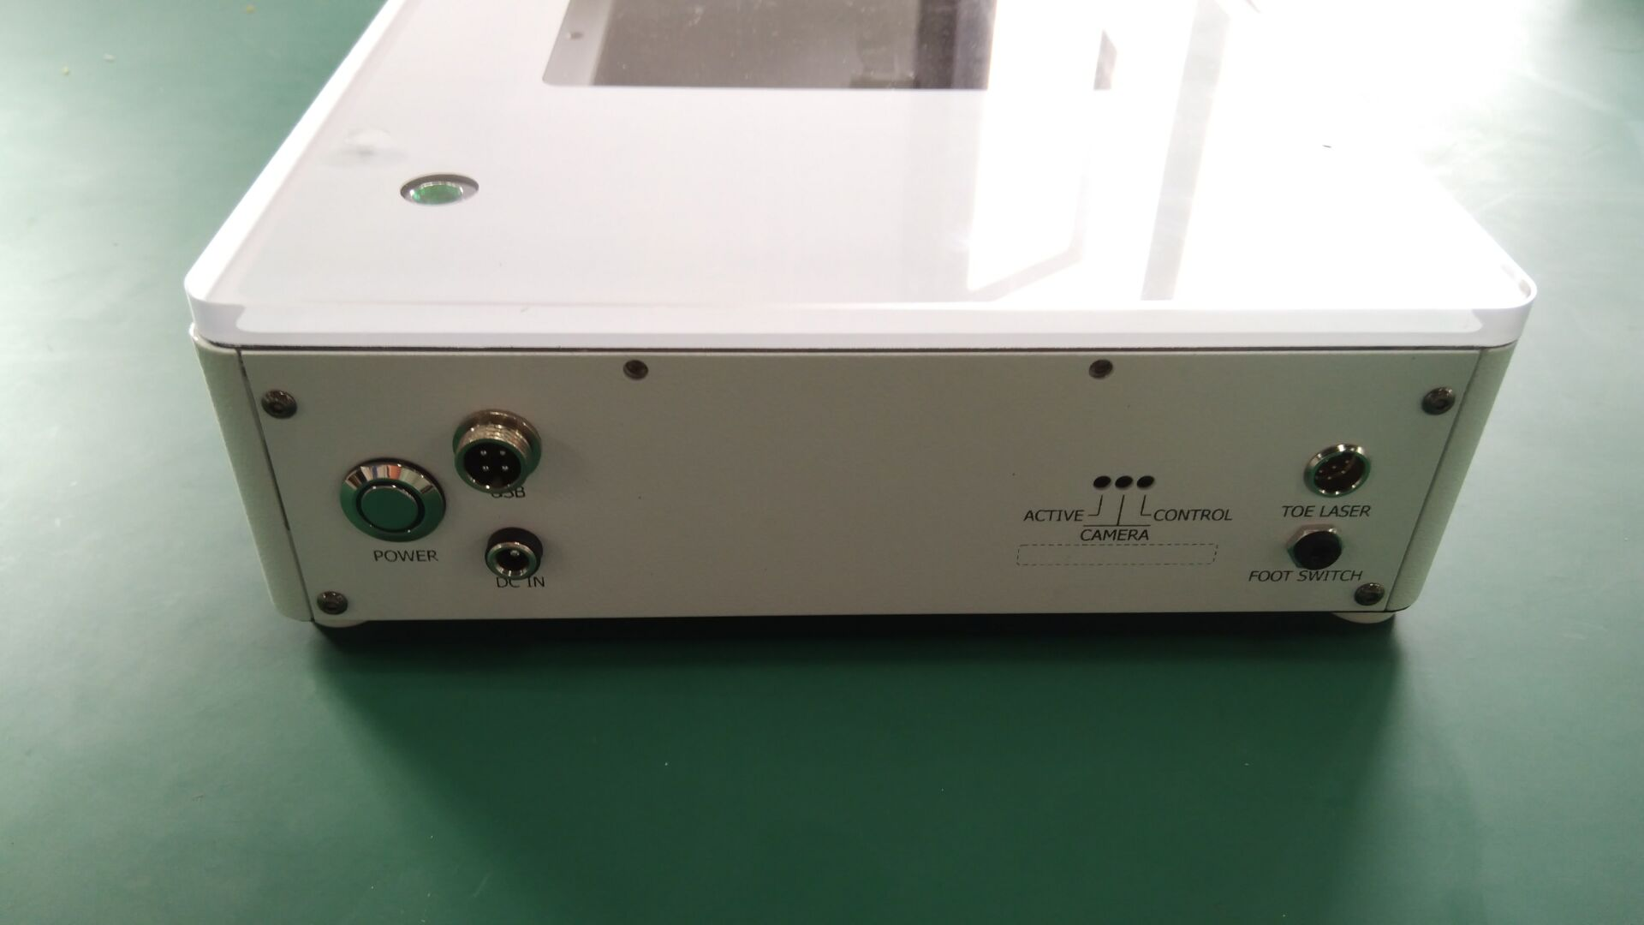 2. 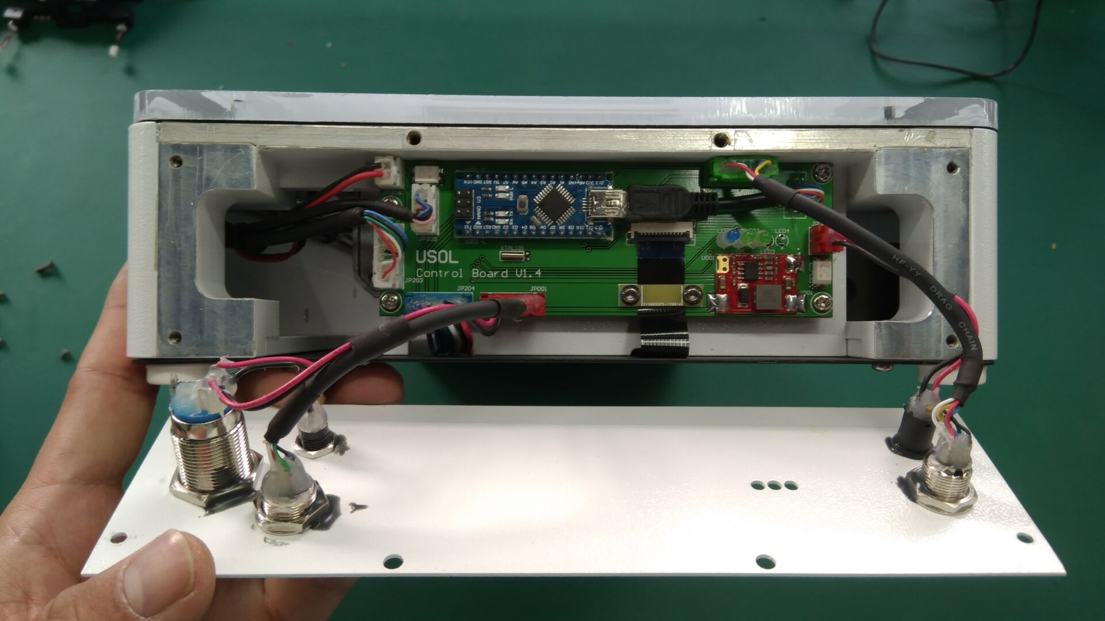
M3*6 X 4PCS
3.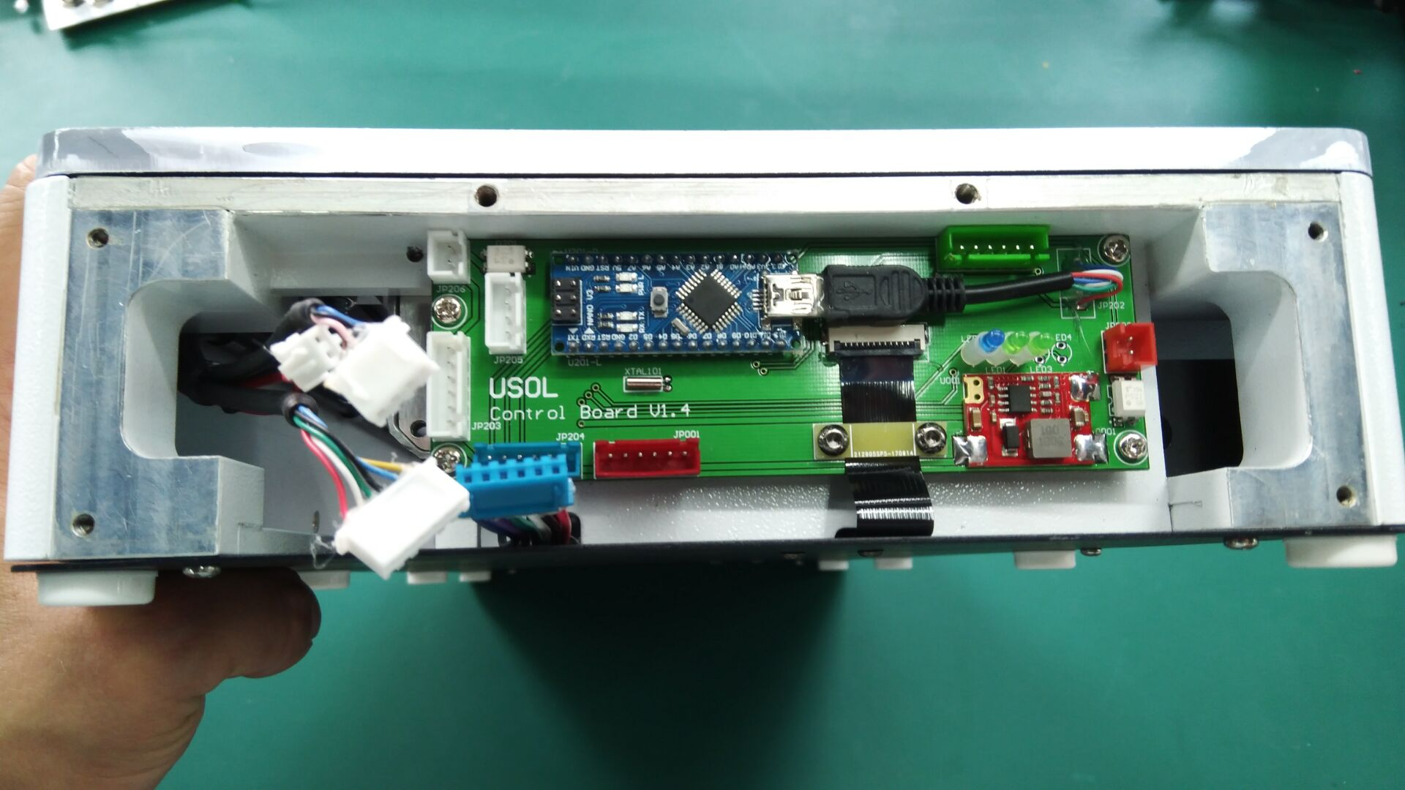 4. 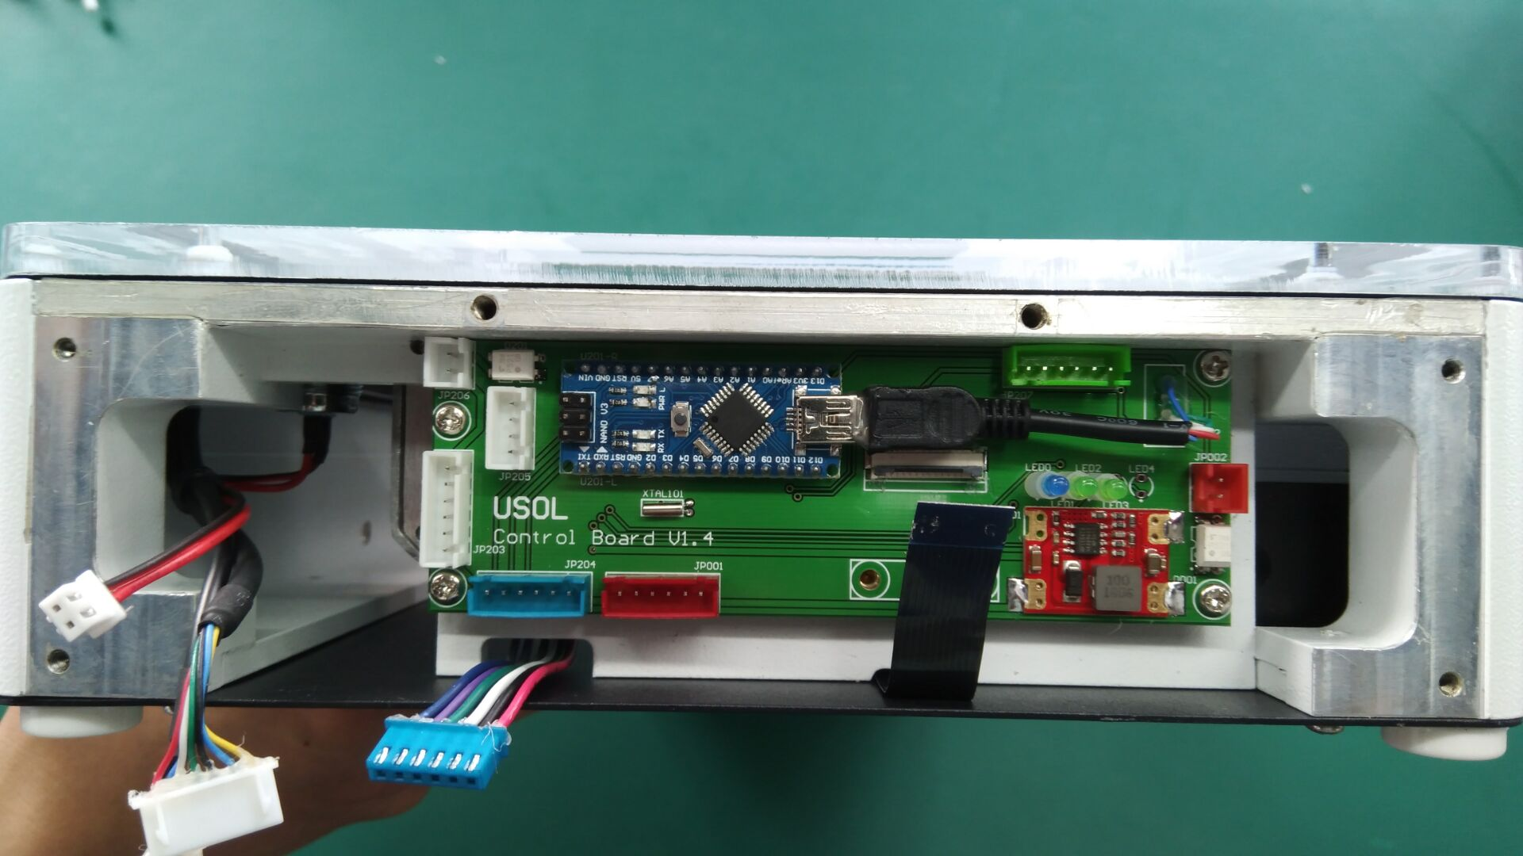
M3*6 X 2PCS

FPC1.0*14P FIip type
M3*5 4PCS

Flip type

